* **Logon on to the Virtual Machine**

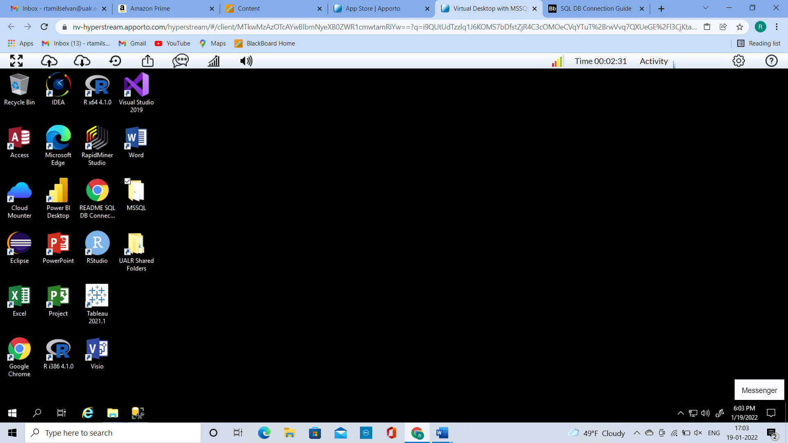

• **Access SQL Server**

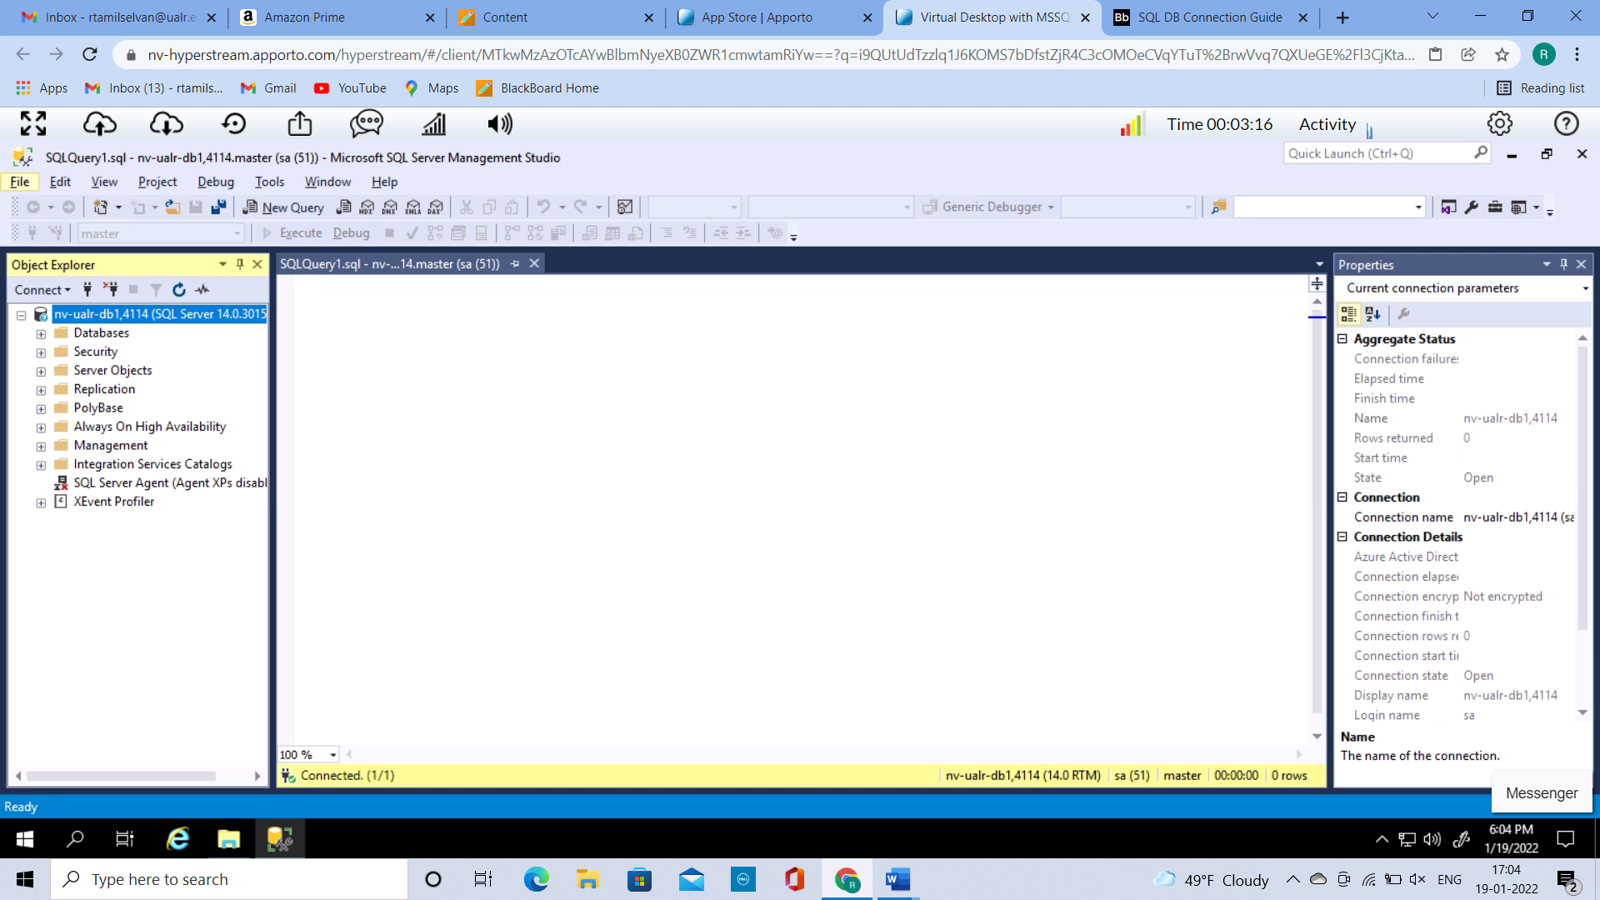

* **Create a ERD(Entity Relationship Diagram)**

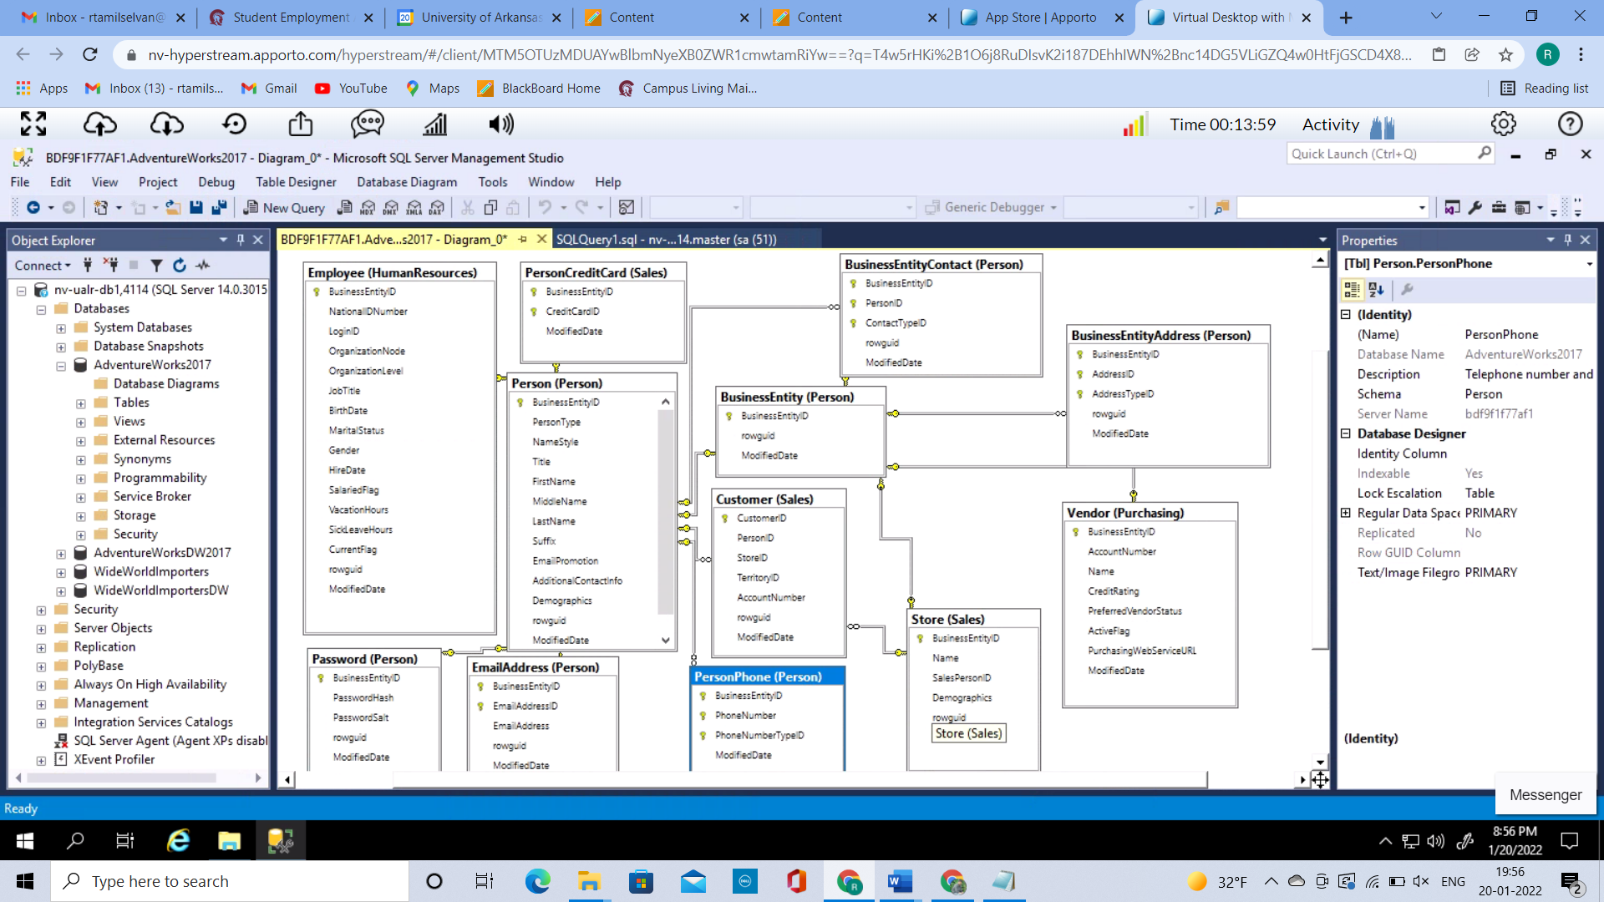

* **Write a basic SQL Select Statement**

Person Query

Select * from person.person

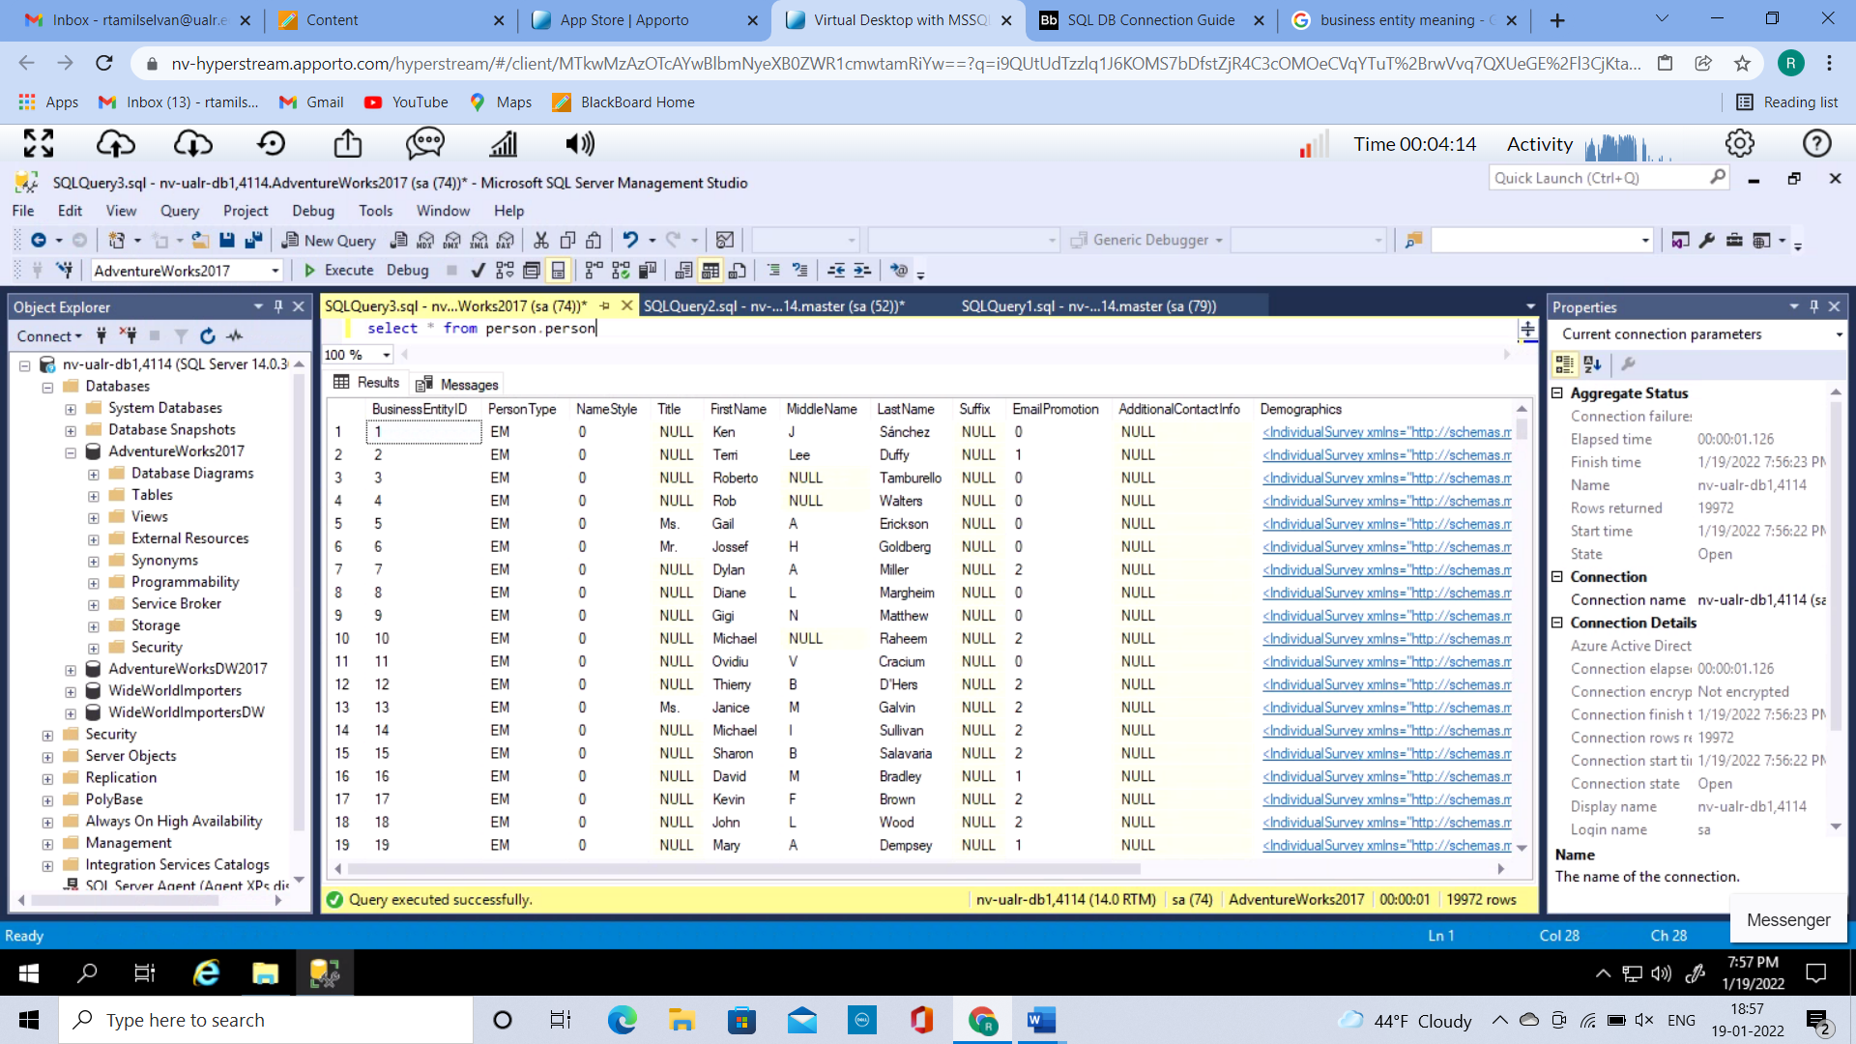

Business Entity Query

select * from person.BusinessEntity

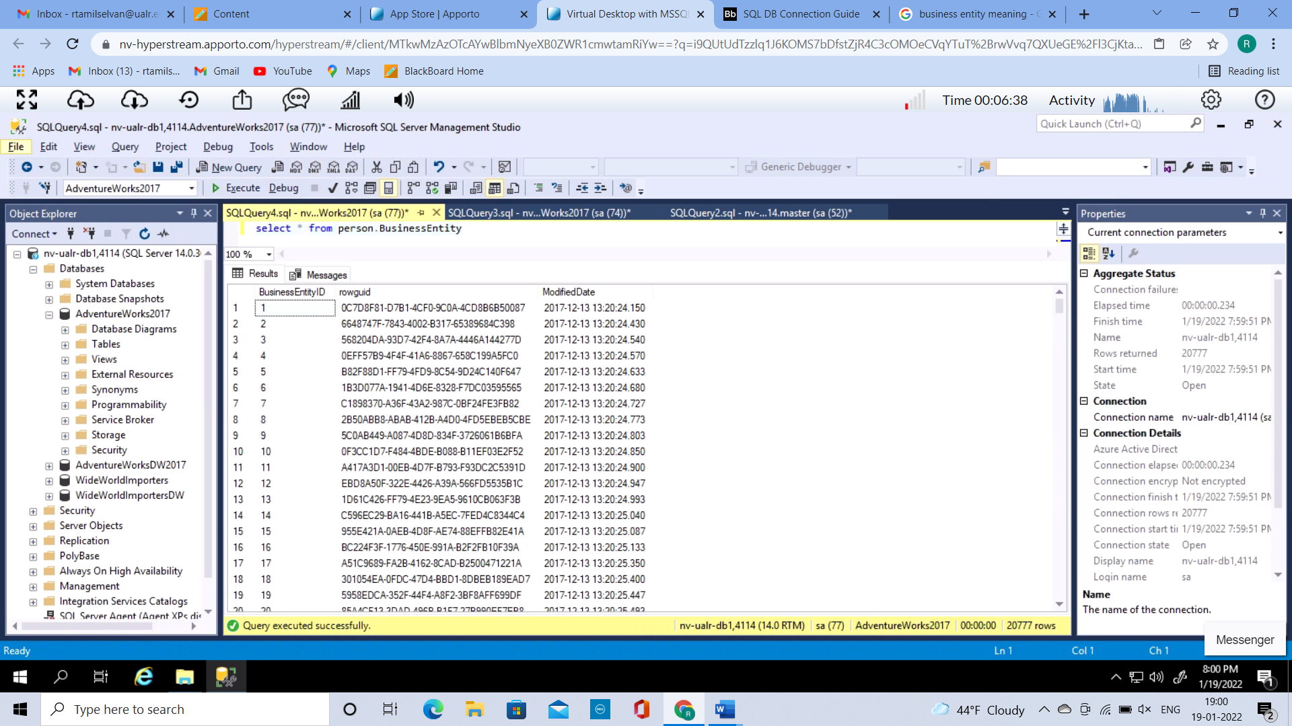

Table Join query

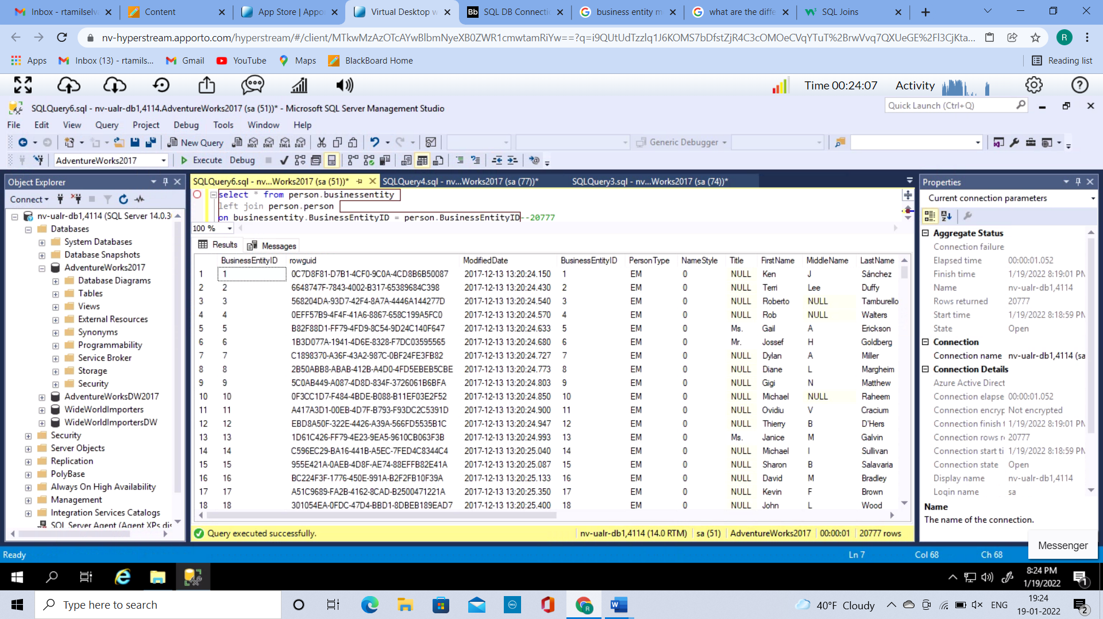

Adding a where clause to the Table join query

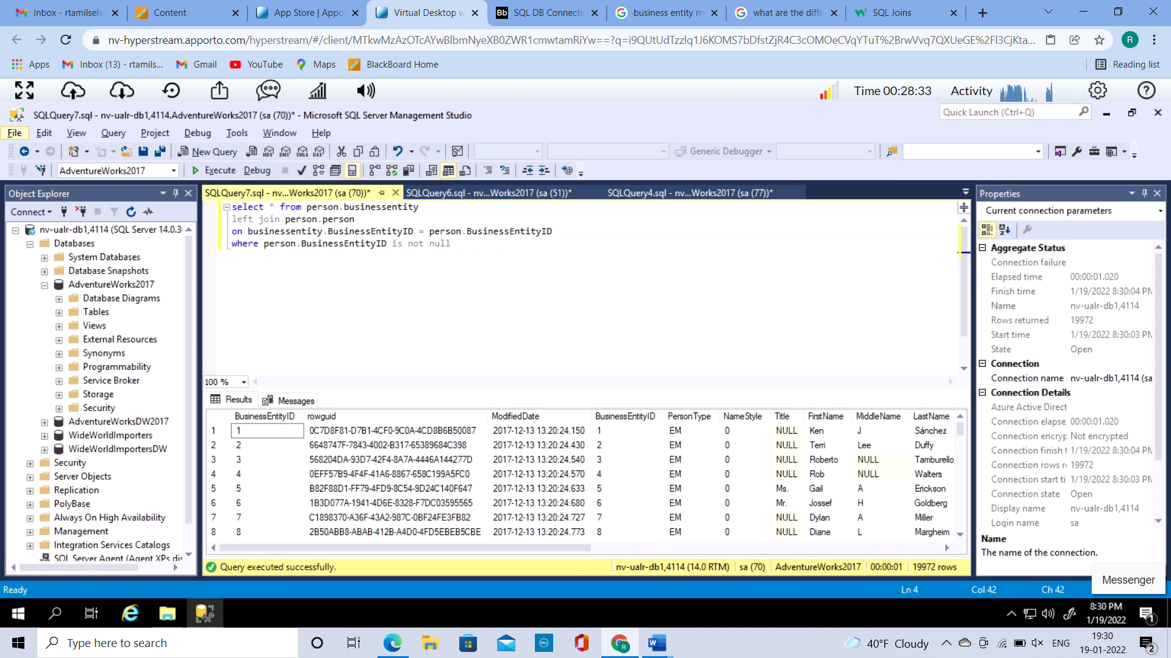

1.How many rows match between the BusinessEntity and Person tables?

19972

2.What do you think the other rows in BusinessEntity are matched to if not Person?

The other rows which are not matched to person table are matched with sales.store table or Purchasing.vendor table or Person.BusinessEntityAddress table.